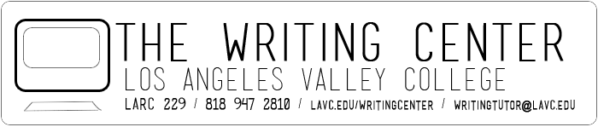
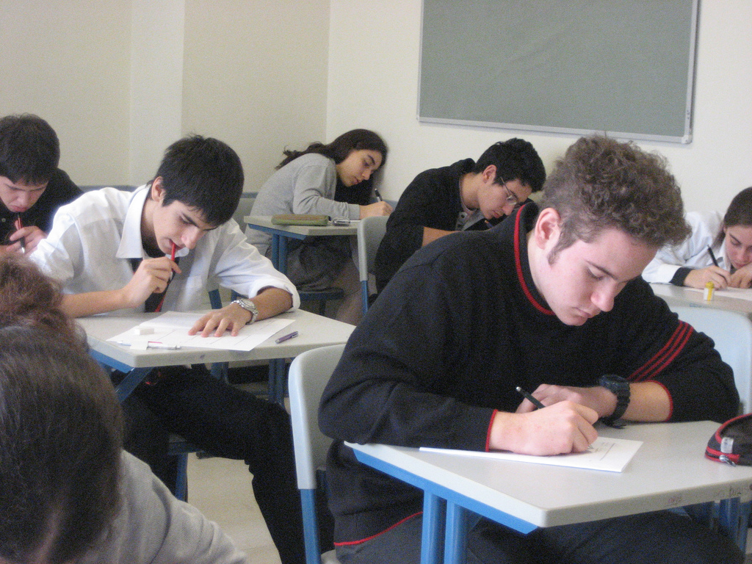
THE IN-CLASS ESSAY EXAM
IS COMING UP
FOR ENGLISH 28/363

THE WRITING CENTER OFFERS A FREE WORKSHOP
TO PREPARE YOU FOR THE EXAM

DO NOT PANIC!
COME TO THE WORKSHOP TO
PRACTICE SAMPLES AND TO GET TIPS ON
MANAGING TIME WHEN WRITING THE IN-CLASS ESSAY
AND
STRUCTURING ACADEMIC ESSAYS

THE WORKSHOP WILL BE AT LARC ROOM 212 ( 2nd floor of the Library Building)
TUESDAY, APRIL 22 1:00-2:30

