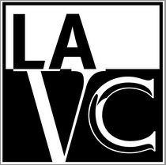
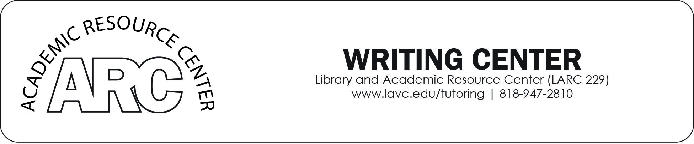

FREE WRITING WORKSHOPS!
Wednesdays & Saturdays
Spring Semester 2016

START THE SEMESTER STRONG: STRATEGIES FOR SUCCESS
Topic |  | Date | Time | Location
1 | Plagiarism: What can be considered a plagiarism? | Wed., 2/17/16 | 1:00 p.m. - 2:30 p.m. | LARC 212
2 | Critical Reading: 3 Pass Approach and Dialectics | Sat., 2/20/16 | 10:00 a.m. -11:30 a.m. | LARC 212
3 | Critical Thinking | Wed., 2/24/16 | 1:00 p.m. - 2:30 p.m. | LARC 212
4 | Composition Family: Differences between Paragraph, Summary, Reflection, Essay, Research | Sat., 2/27/16 | 10:00 a.m. -11:30 a.m. | LARC 212
5 | Scholarship Essay | Wed., 3/2/16 | 1:00 p.m. - 2:30 p.m. | LARC 212
6 | Academic Essay: Types and Structure | Sat., 3/5/16 | 10:00 a.m. -11:30 a.m. | LARC 212
GRAMMAR AND SYNTAX
7 | Parts of Speech | Wed., 3/9/16 | 1:00 p.m. - 2:30 p.m. | LARC 212
8 | Adjectives vs. Adverbs  Subject/Verb Agreement | Sat., 3/12/16 | 10:00 a.m. -11:30 a.m. | LARC 212
9 | Verbs: Types of Verbs/Auxiliary / Tenses | Wed., 3/16/16 | 1:00 p.m. - 2:30 p.m. | LARC 212
10 | Verb Tense/ Aspects | Sat., 3/19/16 | 10:00 a.m. -11:30 a.m. | LARC 212
11 | Active and Passive Voice | Wed., 3/23/16 | 1:00 p.m. - 2:30 p.m. | LARC 212
12 | Clauses, Sentence and their Types | Sat., 3/26/16 | 10:00 a.m. -11:30 a.m. | LARC 212
13 | Sentence Structure and Patterns | Wed., 3/30/16 | 1:00 p.m. - 2:30 p.m. | LARC 212
14 | Run-ons and Punctuation | Wed., 4/13/16 | 1:00 p.m. - 2:30 p.m. | LARC 212
ESSAY WRITING
15 | In-Class Essay Preparation Part 1:  How to Manage your Time and Compose In-Class Essay | Sat., 4/16/16 | 10:00 a.m. -11:30 a.m. | LARC 212
16 | In-Class Essay Preparation Part 2:  How to Structure In-Class Essay and Respond to Questions | Wed., 4/20/16 | 1:00 p.m. - 2:30 p.m. | LARC 212
17 | The Writing Process and Proofreading Strategies | Sat., 4/23/16 | 10:00 a.m. -11:30 a.m. | LARC 212
18 | Paragraph Writing and Unity through Transitions | Wed., 4/27/16 | 1:00 p.m. - 2:30 p.m. | LARC 212
199 | Summary and Reflection | Sat., 4/30/16 | 10:00 a.m. -11:30 a.m. | LARC 212
20 | Sentence Variety: Skeleton and Seasoning of any Writing | Wed., 5/4/16 | 1:00 p.m. - 2:30 p.m. | LARC 212
21 | Essay and Thesis: Types and Structure | Sat., 5/7/16 | 10:00 a.m. -11:30 a.m. | LARC 212
22 | Narrative Essay and its 5 features | Wed., 5/11/16 | 1:00 p.m. - 2:30 p.m. | LARC 212
23 | Argumentative Essay and Appeals of Persuasion | Sat., 5/14/16 | 10:00 a.m. -11:30 a.m. | LARC 212
24 | Critical Reading, Analyzing Literature | Wed., 5/18/16 | 1:00 p.m. - 2:30 p.m. | LARC 212
25 | Validating sources and Integrating Quotes | Sat., 5/21/16 | 10:00 a.m. -11:30 a.m. | LARC 212
26 | Plagiarism and MLA Format and Citation | Wed., 5/25/16 | 1:00 p.m. - 2:30 p.m. | LARC 212
27 | All About Essay Writing and Final Papers | Sat., 5/28/16 | 10:00 a.m. -11:30 a.m. | LARC 212
28 | Business Writing, Resumes, Cover Letter | Wed., 6/1 /16 | 1:00 p.m. - 2:30 p.m. | LARC 212
29 | Screenplay Writing | * TBA | TBA | LARC 229
*Check with Writing Center at LARC 229
All students must bring their LAVC student ID card to attend.
For any information, please call (818) 947-2810.
Workshop materials are posted at http://lavcwcworkshops.weebly.com/

