[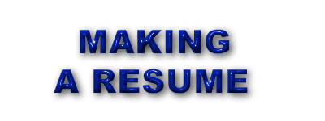](http://rds.yahoo.com/S=96062883/K=resume/v=2/SID=w/l=IVI/SIG=12pou7b9l/EXP=1141102060/*-http:/wwhs.wwps.org/wwhs_career/Career%20Temp%20Data/RESUME_copy.JPG)

This handout is created by Kristina Yegoryan

[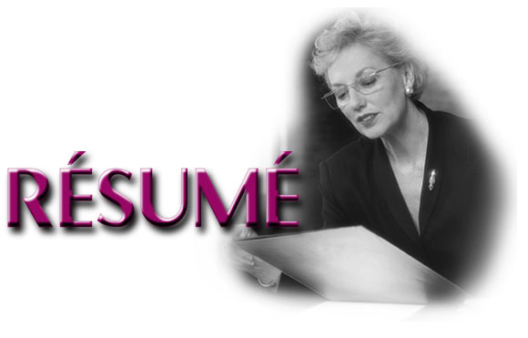](http://rds.yahoo.com/S=96062883/K=resume/v=2/SID=w/l=IVI/SIG=12ju5osel/EXP=1141101886/*-http:/users.deltacomm.com/penny/penny's_site/resume_banner.jpg) is a positive listing of your education, experience and accomplishments.

Resumes should highlight skills and accomplishments that meet employer qualifications, excluding irrelevant information and experiences.

A resume is often the first formal communication with prospective employers. Its purpose is to demonstrate the value you can add to the company, and convince them to

Invite you for an interview.

. [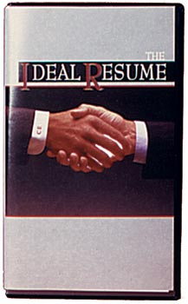](http://rds.yahoo.com/S=96062883/K=resume/v=2/SID=w/l=IVI/SIG=131n0h0i9/EXP=1141100893/*-http:/www.info-motion.net/Merchant2/graphics/00000001/CE_CCP0307V_Resume.jpg)

Well- designed resumes should be written in an organized format that presents the most important information first. It should list briefly all your best and most relevant qualifications for the job you are applying. One –page resumes are preferred for most entry-level positions.

There are different types of resumes to present information related to skills and experiences.

**Chronological Resumes**

***In the chronological resume***, ***job history is organized chronologically with the most*** ***recent job listed first.***

**A chronological resume is advantageous when:**

* Your recent employers and/or job titles are impressive;
* You are staying in the same career field;
* Your job history shows progress:

**A chronological resume is not advantageous when:**

* You are changing career fields:
* You have changed employers frequently:
* You want to de-emphasize age:
* You have been recently absent from the job market or have gaps in employment

# Functional Resumes

***In a functional resume, skills and accomplishments develop through work, academic, and community experiences are highlighted***. Here your skills and potentials can be stressed and lack of experience or possible gaps in work-history de-emphasized.

**A functional resume should be used when**:

* You want to focus on skills and accomplishments rather than a lengthy employment history:
* You are changing career.
* Your career growth in the past has not been continuous and progressive:
* You have a variety of unrelated work experience:
* Your work has been free-lance, or temporary in nature.

**The functional resumes are not advantageous when;**

* You have little work experience
* You want to emphasize promotions and career growth

**Combined Resumes**

This kind of resumes combine elements of the chronological and functional types.

***It*** ***includes the traditional experience section of a chronological resume as well as the skills and accomplishments section of a functional resume.*** This format is advantageous for those who wish to change a job in a related career field or want to promote their marketable skills.



## The categories of information you include on your resume should provide;

* **Contact Section-** presents who are you and how you can be reached.
* **Objective Section-** is to inform of your career goal and targeted interests.
* **Education Section-** if your education doesn’t relates to the work objective, it should
* Be after the experience section. Start with the most recent degree or relevant education.
* **Experience Section-** is accomplishment-oriented and provides an overview of your work experience.
* **Employment Section-**Describe the last three to five positions in detail, and summarize earlier positions unless relevant to your objective. Do not repeat skills that are common to several positions.

## Helpful Hints

* Resume should always be written in the third person without the use of “I” or “me”.
* Try to use proper keywords, especially for the companies who scan resumes.
* Determine appropriate keywords by reading job descriptions.
* Only include personal information where it demonstrates an important personal quality or qualification.
* Avoid using adjective clichés like *“self-motivated”* or *“dynamic”.* Instead, demonstrate these qualities through powerful Action-Benefit statements (showing that your action had a positive benefit).
* Never use the same action verb repeatedly, try to use its synonyms (ex.  ***Instead repeating directed, you may say controlled, guided, supervised, managed, etc).***
* Avoid *italic* and underlining especially for the resumes that will be scanned, as they may cause problems for scanners to read. Use **boldface** or ALL CAPITAL LETTERS if you want to emphasis something.
* Avoid graphics, shadowing, and double spacing within sections.
* Print your (especially scan able) resume in black ink only, using a standard fonts and letter size, on a white or cream paper (size 8.5x11).
* When mailing use a large envelope that accommodates it without folding.
* **KEEP IT SIMPLE!**



**Key resume phrases and words**

To make your resume more readable and effective use the following phrases and words:

* Established
* Edited
* Managed
* Maintained
* Assisted with
* Coordinated
* Delegated
* Developed
* Consulted
* Presented
* Successful in/at
* Knowledge of/experienced as
* Initially employed
* Proficient /competent at
* Sales quote accountability
* Accomplished
* Demonstrated
* Experience involved / included
* Expertise and demonstrated skills
* Extensive training / involvement
* Specialize in
* Temporarily assigned to
* In charge



**For further references see also:**

Cooperative Education Dep. of LAVC. A Handout on Resume Writing.

Kramer, R. Mark. Resume Maker Professional. CA:

Individual Software Inc. Copyright,

2003.

National Resume Writers Association. A Guide To Writing Resumes That

Make an Impression.